AI-Enhanced Intrusion Detection System
Project Report

1. Introduction :
With the rapid growth of internet usage and digital technologies, cyber threats have become a major concern for individuals and organizations. Attackers continuously attempt to exploit network vulnerabilities, leading to data breaches, financial losses, and security risks.
Therefore, detecting malicious network activities at an early stage is essential for maintaining network security.The AI Enhanced Intrusion Detection System is a machine learning-based cybersecurity application developed to identify malicious network traffic and distinguish it from normal traffic. The system uses a Random Forest Classifier trained on a balanced dataset containing network traffic records. Based on selected network traffic features such as Flow Duration, Total Forward Packets, Total Backward Packets, and Total Length of Forward Packets, the model predicts whether the traffic is BENIGN or ATTACK.The trained model is integrated into a Flask web application that provides a simple and interactive user interface. Users can enter network traffic values and instantly receive prediction results. The project demonstrates how Artificial Intelligence and Machine Learning can be used to improve cybersecurity by automating intrusion detection and supporting faster threat identification.

Project member :
Developed By: Rohit Yadav

1.1 Project Overview :
The AI Enhanced Intrusion Detection System is a cybersecurity web application developed using Python, Flask, and Machine Learning techniques. The system is designed to identify malicious network traffic and distinguish it from normal network behavior in real time. Traditional security systems often rely on predefined rules and signatures, making it difficult to detect unknown threats. To overcome this limitation, this project utilizes a Random Forest Classifier trained on balanced network traffic data.
The application provides a user-friendly cyberpunk-themed web interface where users can enter network traffic parameters and instantly receive a prediction indicating whether the traffic is BENIGN (safe) or ATTACK (malicious). The system demonstrates the practical application of Artificial Intelligence in modern cybersecurity environments.

2. Objectives :
The main objectives of the project are:
To develop an AI-powered intrusion detection system.
To classify network traffic as BENIGN or ATTACK.
To improve network security using machine learning techniques.
To provide real-time attack detection through a web application.
To reduce manual analysis of network traffic.
To create a visually appealing and interactive cybersecurity dashboard.

3. Project Initialization and Planning Phase:

3.1 Define Problem Statement :
Cyber attacks are increasing rapidly, making network security a major concern for organizations. Traditional intrusion detection systems rely on static rules and signature databases, which are often unable to detect new attack patterns effectively.
Problem Statement:
"To develop an intelligent intrusion detection system capable of analyzing network traffic features and automatically identifying malicious activities using machine learning algorithms."

3.2 Project Proposal (Proposed Solution) :
The proposed solution is a machine learning-based web application that analyzes network traffic characteristics and predicts whether the traffic is normal or malicious.
The system consists of:
Data collection and preprocessing
Machine learning model training
Model deployment using Flask
Interactive web-based user interface
Real-time attack prediction module
The Random Forest algorithm was selected due to its high accuracy, robustness, and ability to handle complex datasets.

3.3 Initial Project Planning :
Project Modules :

Module
Description
Data Collection
Collect intrusion detection dataset
Data Preprocessing
Clean and balance dataset
Model Training
Train Random Forest classifier
Model Evaluation
Evaluate model performance
Flask Integration
Connect model with web application
Frontend Development
Design cyberpunk user interface
Testing & Deployment
Test system and deploy locally

4. Data Collection and Preprocessing Phase :
4.1 Data Collection Plan and Raw Data Sources Identified :
The dataset used in the project is:
web_attacks_balanced.csv
The dataset contains network traffic records consisting of normal and malicious traffic samples.
Important features selected for model training:
Flow Duration
Total Forward Packets
Total Backward Packets
Total Length of Forward Packets
Target Classes:
BENIGN
ATTACK
The dataset was balanced using the imbalanced-learn library to ensure fair classification performance.

4.2 Data Quality Report :
The dataset was analyzed for quality issues before model training.
Data Quality Checks Performed
Missing value detection
Duplicate record analysis
Data balancing verification
Feature consistency check
Label verification
Observations
No major missing values were detected.
Dataset classes were balanced successfully.
Selected features showed useful correlation with attack behavior.
Data was suitable for machine learning training.

4.3 Data Preprocessing :
The following preprocessing steps were performed:
Dataset loading using Pandas
Feature extraction
Label encoding
Data balancing using imbalanced-learn
Train-test split
Feature scaling where required
Benefits:
Improved classification accuracy
Reduced bias towards majority classes
Better model generalization

5. Model Development Phase :
5.1 Model Selection Report :
Several machine learning algorithms were considered for intrusion detection.
Selected Algorithm : Random Forest Classifier
Reasons for Selection:
Handles non-linear relationships effectively.
Resistant to overfitting.
Works well on balanced datasets.
Provides high prediction accuracy.
Fast inference suitable for real-time deployment.
Libraries Used:
Scikit-learn
Pandas
NumPy
Joblib

The trained model was stored as:
random_forest_model_4_features.joblib

5.2 Initial Model Training, Validation and Evaluation Report :
Training Process
Dataset imported into Jupyter Notebook.
Four important features selected.
Dataset split into training and testing sets.
Random Forest model trained.
Performance evaluated using test data.
Evaluation Metrics
Accuracy
Precision
Recall
F1 Score
Confusion Matrix
The model demonstrated strong performance in distinguishing malicious and normal traffic.

6. Model Optimization and Tuning Phase :

6.1 Tuning Documentation :
To improve model performance:
Multiple Random Forest configurations were tested.
Number of decision trees adjusted.
Tree depth optimized.
Feature selection refined.
Balanced dataset used for training.
Optimization Goals
Increase detection accuracy
Reduce false positives
Improve prediction speed

6.2 Final Model Selection Justification :
Random Forest was selected as the final model because it:
Produced reliable predictions.
Required minimal feature engineering.
Performed well on balanced datasets.
Provided fast response time for web deployment.
Reduced risk of overfitting compared to individual decision trees.

7. Results :
The developed system successfully classifies network traffic into BENIGN and ATTACK categories through a web interface.
Key Results
Real-time intrusion detection.
Instant prediction generation.
User-friendly web interface.
Effective attack classification.

7.1 Output Screenshots
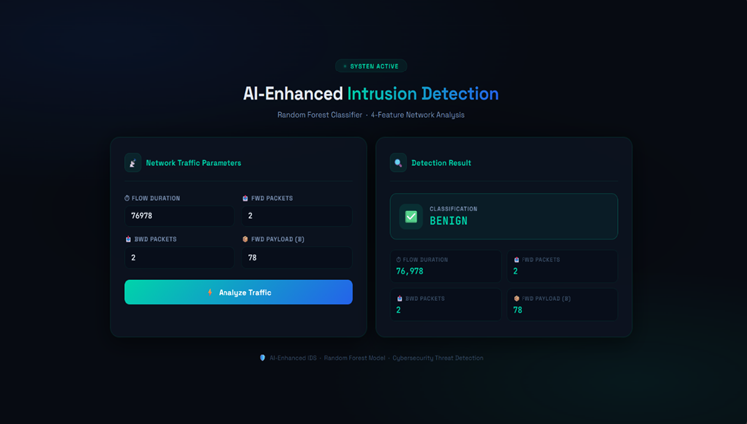
FIG 1: Detection 1
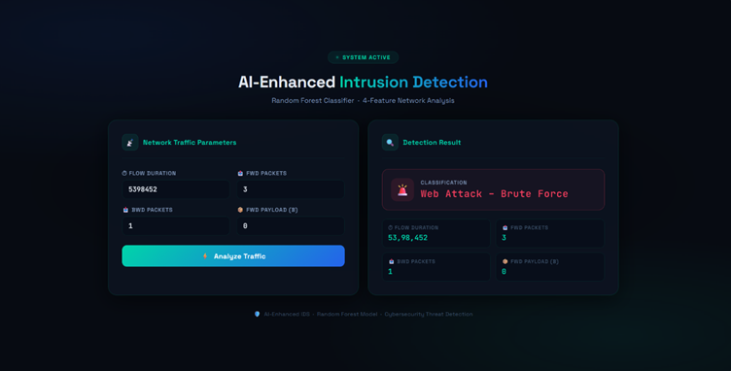
FIG 2: Detection 2

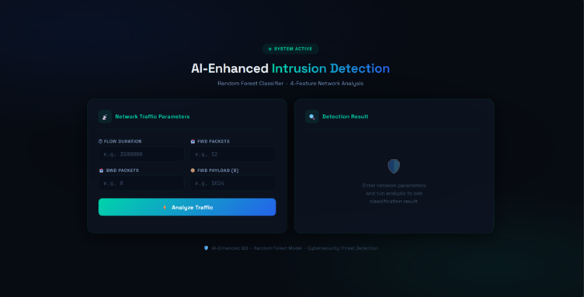
FIG 3: Home page

8. Advantages and Disadvantages :

8.1 Advantages :
Real-time intrusion detection.
High prediction accuracy using Random Forest.
Balanced dataset improves classification fairness.
Attractive cyberpunk user interface.
Lightweight Flask deployment.
Easy to use.
Fast prediction speed.
Self-contained application

8.2 Disadvantages :
Requires manual data entry.
Uses only four traffic features.
Cannot capture live network packets.
Limited to attack patterns present in training data.
Requires retraining for emerging threats.
No user authentication mechanism.

9. Conclusion :
The AI Enhanced Intrusion Detection System successfully demonstrates how Artificial Intelligence and Machine Learning can be applied to cybersecurity problems. By using a Random Forest classifier and a Flask-based web application, the system can accurately classify network traffic as normal or malicious. The project provides an effective, lightweight, and user-friendly solution for intrusion detection and serves as a strong foundation for future cybersecurity applications.

10. Future Scope :
The project can be extended with the following features:
Live packet capture using Python Scapy.
Deep Learning models such as CNN and LSTM.
Real-time traffic monitoring dashboard.
Cloud deployment using AWS or Azure.
Mobile application integration.
Email and SMS alert system.
User authentication and role management.
Automated attack response mechanisms.
Threat history tracking and reporting.

11. Appendix :
11.1 Source Code :
Main Files:
app.py
index.html
random_forest_model_4_features.joblib
Untitled.ipynb
web_attacks_balanced.csv
Libraries Used:
Flask
Scikit-learn
Pandas
NumPy
Joblib
Imbalanced-learn

